**Simulator Installation**

The simulator that we are going to use for our current task is called C/C++ simulator.

**What is a ROBOT SIMULATOR?**

A robot simulator is a software that allows you to observe or predict the behavior of a robot without using any actual physical parts. It, therefore, gives you the advantage of learning without having to bear the loss of your mistake in your actual robot.

**Installing C/C++ Simulator**

Follow the step by step guide to install the C/C++ simulator [here.](https://www.suntos.com.np/robotics-bootcamp/installing-robotics-simulator.html#system-requirements)

**Run a Demo Program**

After installing and opening the simulator you will see a robot on a square map on the right and a space to write your codes on the left. The right screen is the environment of the robot and the left screen is your code screen. The robot on the right will behave according to the code written on the left.

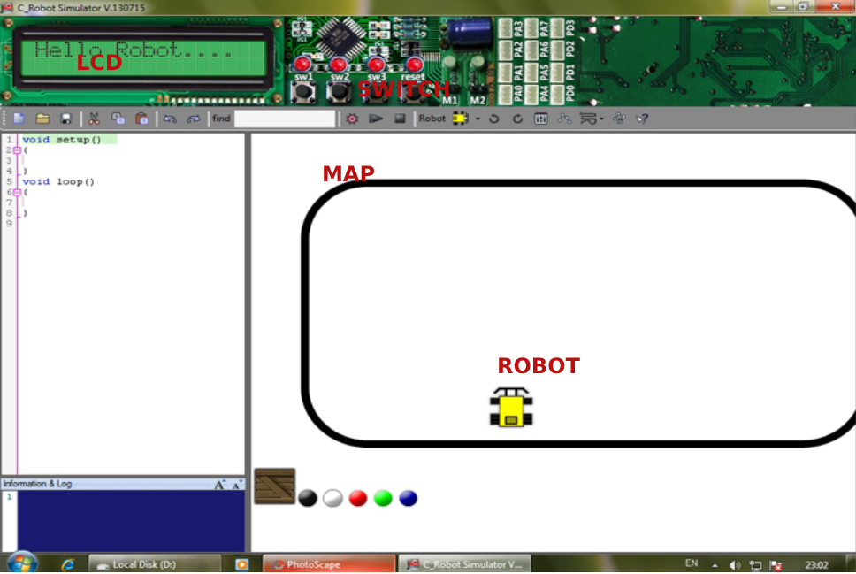

So run your first sample code as here.

void setup(){

}

void loop{

fd(100);

sleep(1000);

tr(100);

sleep(1000);

tl(100)’;

sleep(1000);

fd(100);

}

After writing the code, you click the play button in the upper bar.

The robot should move forward, turn right, turn left, and again move forward.